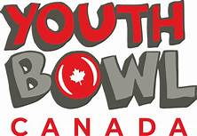
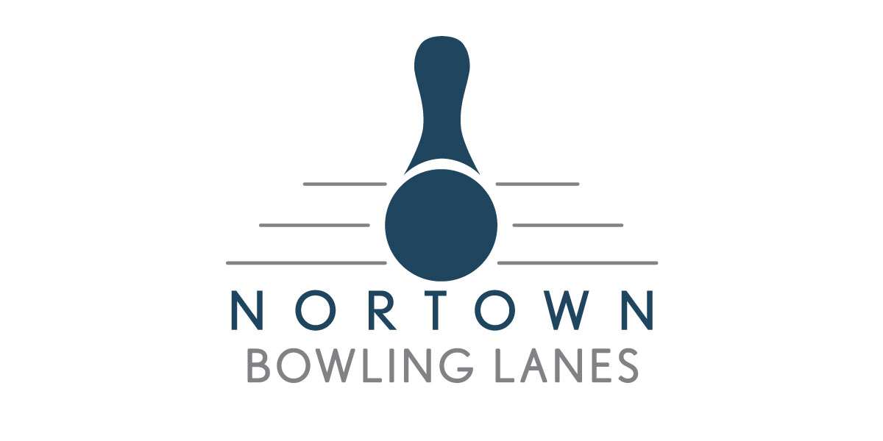
NORTOWN LANES – Youth Bowl Canada Program

We would like to introduce any new bowlers to YBC by offering a chance to try
during the month of September without paying the registration fee and only
need to pay for the weekly cost (see below)!
If after that month is done and you would like to continue, we then ask for a $80.00 registration fee.

Early registration fee of $70.00 will be accepted until August 15th, 2023.
(After this date the fee will be $80.00)
This fee covers national body dues, tournaments, awards, yearly events and a wind-up function.
Bowling shirts can be purchased at a cost of $55.00/bowler to cover this. The shirt must be worn for all of our tournaments.

Monthly bowling fees include shoe rental, game costs and an award fund recognizing each bowler’s achievements
at the end of the season.

All registered bowlers that are registered with Youth Bowl Canada are required to participate in the annual national body fundraiser, which aids all YBC bowlers across Canada. Each registered bowler is required to pre-purchase a minimum of one case of chocolates to sell prior to November 30th. (Approximately $125 per case)

Parent participation helps in making this program successful.
If you would like to volunteer with our program, please let us know at the time of registration.

Age Groups (as of Dec. 31/2023) Bowling Times # of Games Monthly Cost
DINOS (5 and under) Saturday - 10:30 am 1 Game $28.00
JET (7 and under) Saturday - 10:30 am 2 Games $40.00
BANTAM (10 and under) Saturday - 10:30 am 3 Games $56.00
JUNIOR (14 and under) Saturday - 10:30 am 3 Games $56.00
Or Sunday – 6:30
SENIOR (19 and under) Sunday – 6:30 pm 3 Games $56.00

***ALL Prices subject to change ***
Receipt of Payment

E-Transfer: Cash: Other:
(Child’s name will need to be included in message field when an E-Transfer is sent)
………………..……...………..…………………………..……………..

(It is very important that the form below is legible and correctly filled out.)

Bowler’s Name: ______________________________________ Phone Number: _________________

Address: ____________________________________________ Alt. Phone Number: ____________ _

Postal Code: _________________ Sex: F M

Birth Date: Month: ______ Day: _____ Year: _____ Age as of Dec 31st: _____

Age Group: _____________

Request to bowl with (if possible): ____________________________

Parent Signature: _____________________________________________

Parents PRINTED name: _________________________________________

Email address: __________________________________________ _

Office Use Only: Bowl Canada Registration Number __________________

E-Transfer Date and Amount: Cash: Other:

